**SQL SALES PROJECT REPORT:**

**TOOLS**:Sql online server,data collection from kuggle

**1. Table Creation**

CREATE TABLE retail_sales (

transactions_id INT PRIMARY KEY,

sale_date DATETIME,

sale_time VARCHAR(8),

customer_id INT,

gender VARCHAR(6),

age INT,

category VARCHAR(11),

quantity INT,

price_per_unit INT,

cogs NUMERIC(5, 2),

total_sale INT

);

**2. Select All Data**

**Select * from retail sales;**

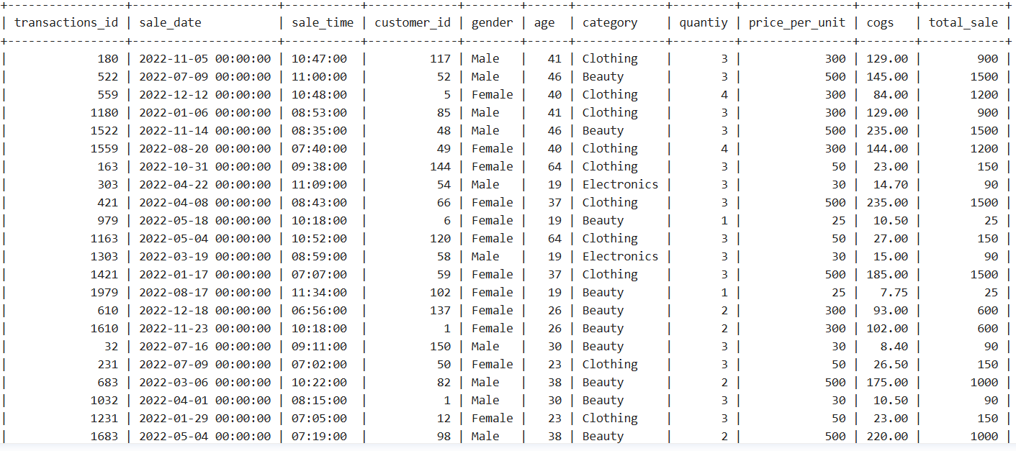

Select * from limit 5;

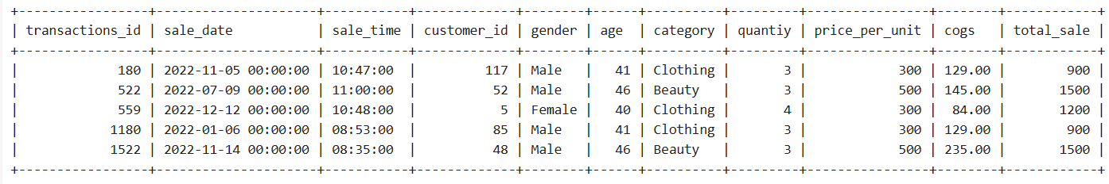

**3. SELECT with WHERE, ORDER BY, GROUP BY**

* Find all sales where quantity > 2, ordered by total_sale descending:

SELECT * FROM retail_sales

WHERE quantity > 2;

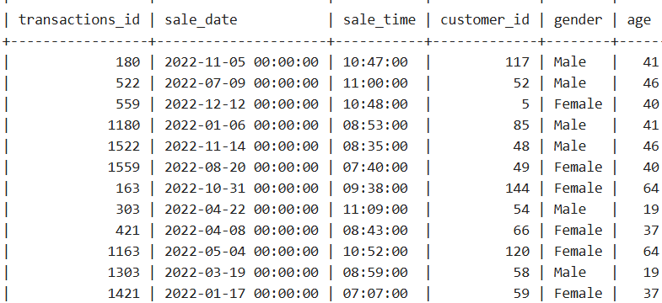

SELECT category, SUM(total_sale) AS total_category_sales

FROM retail_sales

GROUP BY category

ORDER BY total_category_sales DESC;

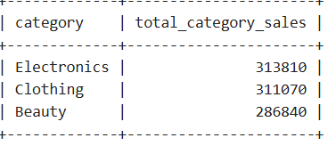

**4. JOINS**

CREATE TABLE customers (

customer_id INT PRIMARY KEY,

customer_name VARCHAR(50),

city VARCHAR(50)

);

* **INNER JOIN** retail_sales and customers on customer_id:

SELECT r.transactions_id, c.customer_name, r.total_sale

FROM retail_sales r

INNER JOIN customers c ON r.customer_id = c.customer_id;

* **LEFT JOIN** to get all sales even if customer info is missing:

SELECT r.transactions_id, c.customer_name, r.total_sale

FROM retail_sales r

LEFT JOIN customers c ON r.customer_id = c.customer_id;

* **RIGHT JOIN** to get all customers, even if they have no sales:

SELECT r.transactions_id, c.customer_name, r.total_sale

FROM retail_sales r

RIGHT JOIN customers c ON r.customer_id = c.customer_id;

**5. Subqueries**

* Find transactions where total_sale is greater than average sale:

SELECT sales,category

FROM retail_sales

WHERE total_sale > (SELECT AVG(total_sale) FROM retail_sales);

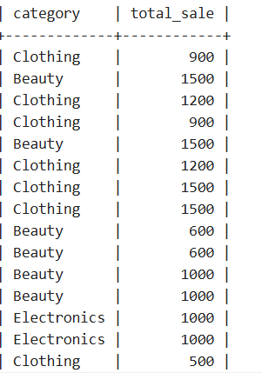

**6. Aggregate Functions**

* Sum and Average total_sale by gender:

SELECT gender, SUM(total_sale) AS total_sales, AVG(total_sale) AS average_sales

FROM retail_sales

GROUP BY gender;

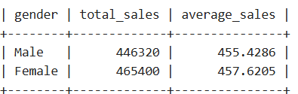

**7. Views**

Create a view for total sales per category:

CREATE VIEW category_sales AS

SELECT category, SUM(total_sale) AS total_category_sales

FROM retail_sales

GROUP BY category;

SELECT * FROM category_sales ORDER BY total_category_sales DESC;

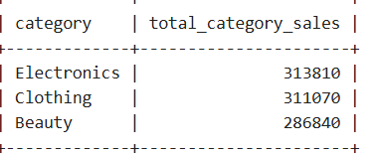

**8. Indexes for Optimization**

Create an index on customer_id and category to speed up queries:

CREATE INDEX idx_customer ON retail_sales(customer_id);



**Conclusion**:

This report demonstrates comprehensive data analysis using SQL on a retail sales dataset. The analysis included foundational SQL operations such as SELECT, WHERE, ORDER BY, and GROUP BY, as well as more advanced techniques including JOINs, subqueries, aggregate functions (SUM, AVG), views, and indexing.

From the queries, we derived valuable insights such as:

* Gender-based sales performance, showing whether male or female customers contributed more to total sales.
* Category-wise sales analysis, identifying the most popular and profitable product categories.
* Use of indexing to optimize query performance for faster retrieval of key business metrics.

NOTE:

I sdon’t have SQL installed on my system, so I used an online SQL server instead.

